# Personal Communications Assistant

Subscribers use Cisco Personal Communications Assistant (PCA) to access Messaging Assistant and Web Inbox. Messaging Assistant provides subscribers the ability to customize personal settings from their computers. Customized options include recorded greetings or message delivery options. Web Inbox allows subscribers to manage voice messages through a web interface.

## Accessing PCA

Using a web browser, navigate to: <https://voicemail.xyz.com/ciscopca>



* At the User Name and Password prompts, enter the following:
* User Name: Active Directory user name
* Password: Active Directory password
* From this page the subscriber may access **Messaging Assistant** or **Web Inbox**.

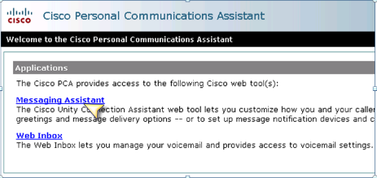

### Changing a Phone Personal Identification Number (PIN)

A phone PIN protects the privacy of messages and secures the Cisco Unity Connection account from unauthorized access. Subscribers can change their phone PIN at any time.

When changing a phone PIN, follow the security guidelines provided by the Cisco Unity Connection administrator. In general, shorter PINs are easier to use, but longer PINs are more secure, especially using a nontrivial PIN. The phone PIN must be at least **six** characters long.

A nontrivial PIN means:

* The PIN is not the same as previous PINs.
* The digits are not all the same (for example, 9999).
* The digits are not consecutive (for example, 1234).
* The PIN is not the same as the extension.
* The PIN does not spell the subscribers name.

**Changing a Phone PIN**

From the **Passwords** drop-down menu:

1. Select **Change PIN**.

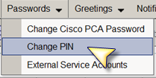

1. In the **New PIN** box enter a PIN using digits 0 thru 9.
2. In the **Confirm New PIN** box enter the PIN again.

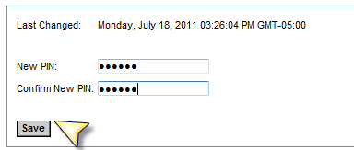

1. Select the **Save ** button.